**LABS**

Offer Letter

Date: 6th October 2022 Dear Atharva,

We are pleased to offer you the position of **Software Engineer** for **Pune** location at **Fortytwo42 Technology Innovations Pvt. Ltd.** We feel confident that you will contribute your skills & experience to the growth of our organization.

In this position, the company is offering you a compensation of **INR 6,00,000/-LPA (INR 5,00,000 Fixed + INR 1,00,000 Performance Bonus)** as and your starting date will be **1st June 2023**.

Please indicate your agreement with these terms and accept this offer by signing this letter on or before 7th October 2022.

We look forward to welcoming you to FT42 family.

Sincerely,

# FOR FORTYTWO42 TECHNOLOGY INNOVATIONS PRIVATE LIMITED

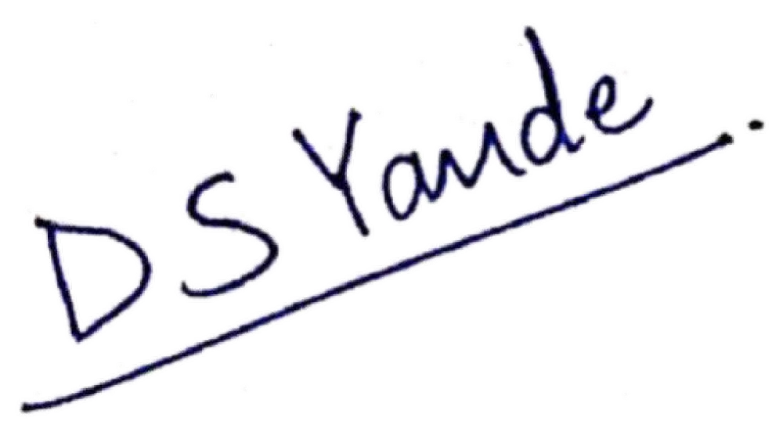

**Dnyanda Yande**

# Human Resource Manager

**EMPLOYEE ACKNOWLEDGEMENT AND ACCEPTANCE**

I accept and agree to abide by the above in this offer of employment. I shall keep the contents of this document confidential.



# Mr. Atharva Tilak

**FORTYTWO42 TECHNOLOGY INNOVATIONS PVT.LTD.**

**(Registered Address) Office No 201, 2nd Floor, Siddh Icon, Baner Road, Pune – 411045. Maharashtra, INDIA. Email:** [**info@fortytwo42.in**](mailto:info@fortytwo42.in) **Contact No – 9823348880**

**Website –** [**www.fortytwo42.in**](http://www.fortytwo42.in/) **CIN - U74999PN2016PTC157768**